**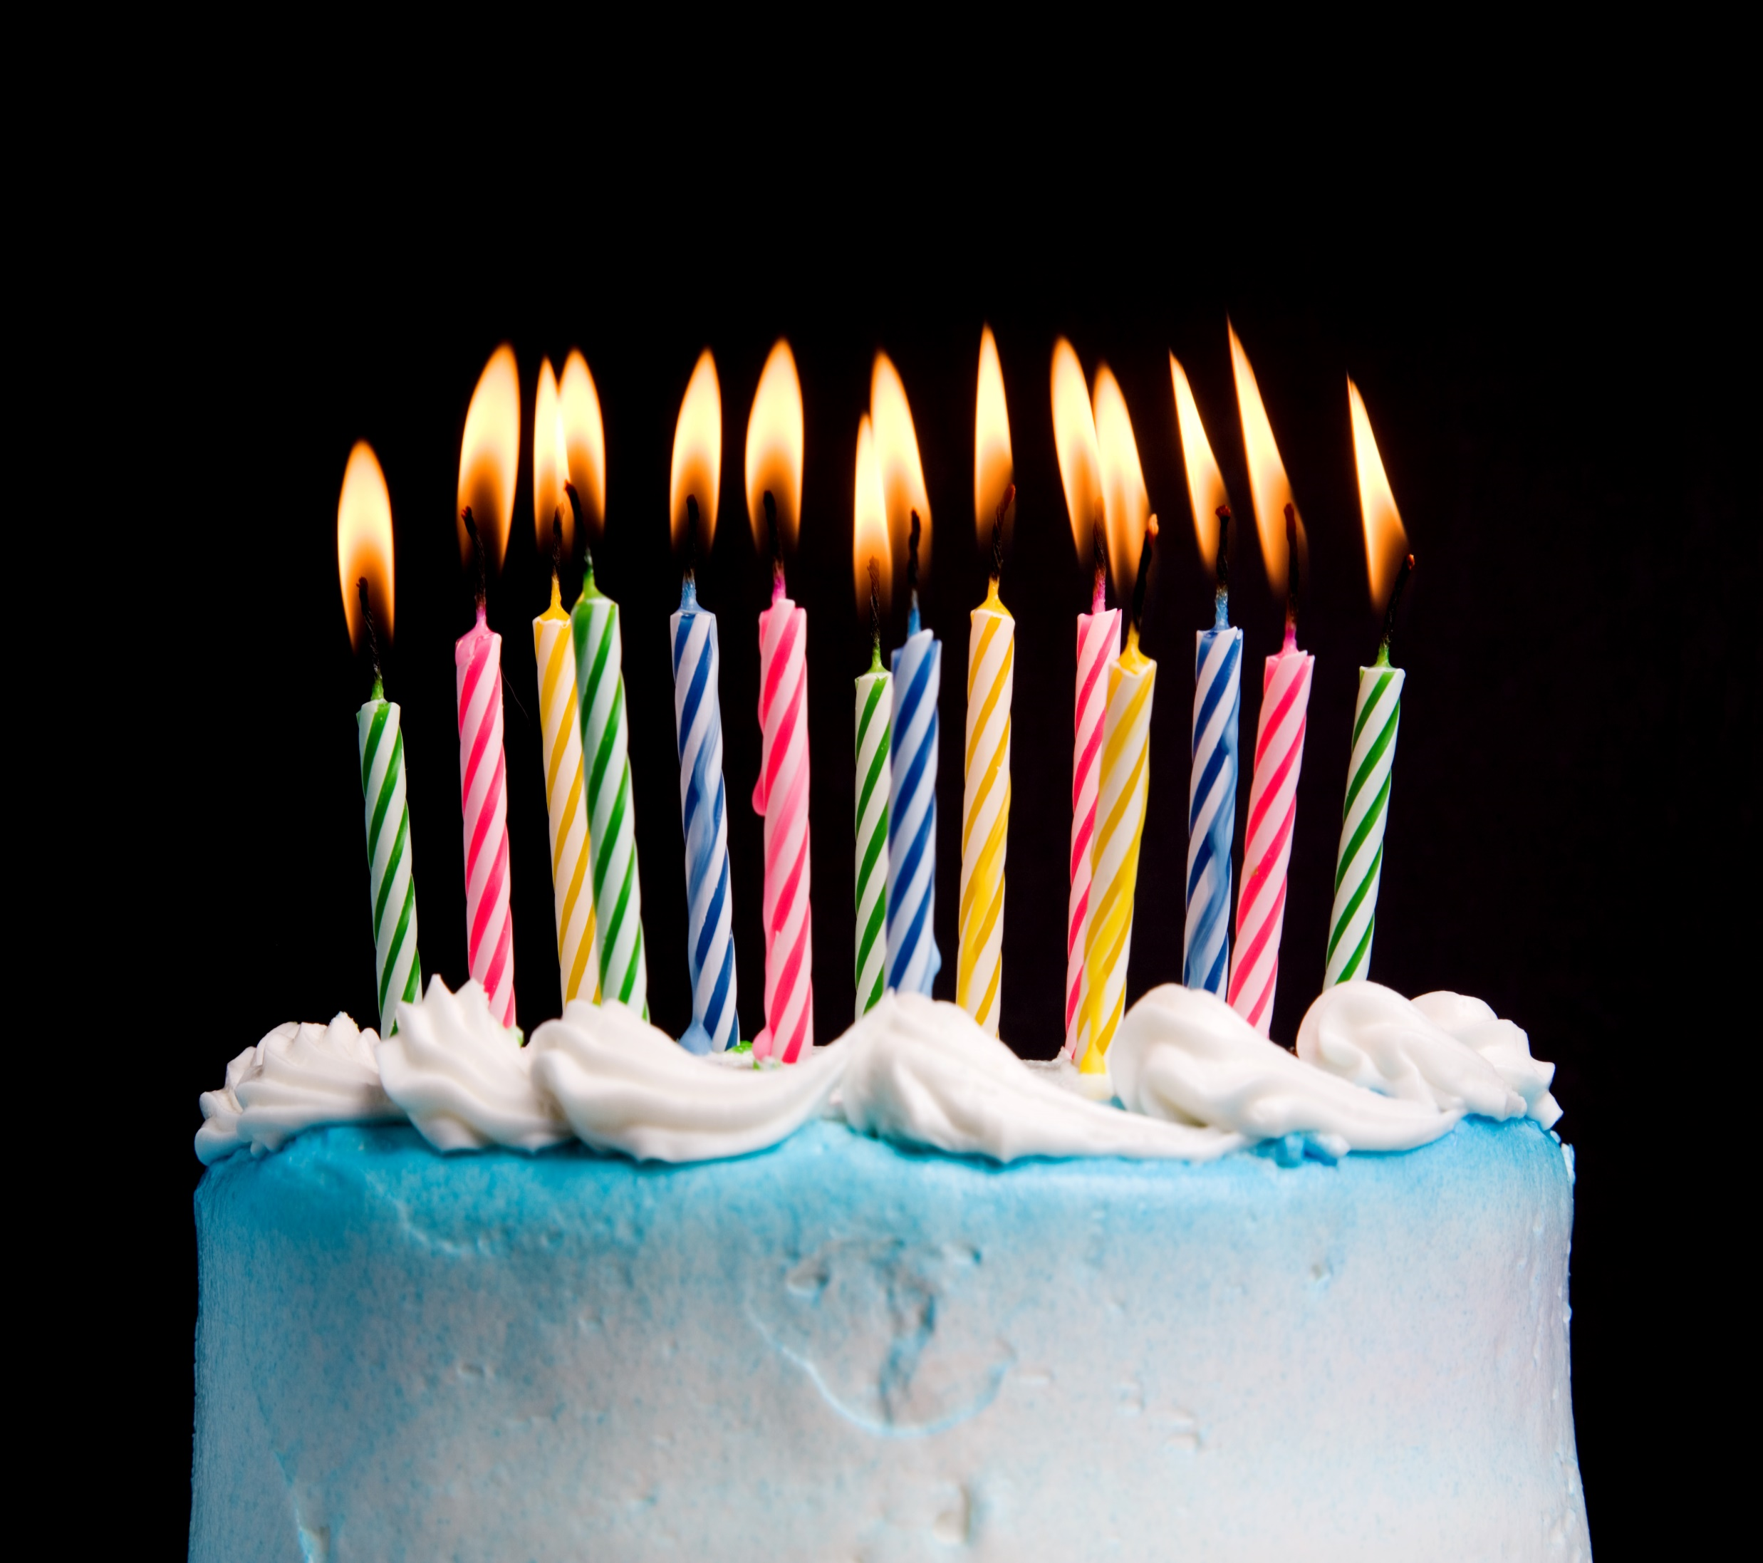****To the dearest harry barry:**

**HAPPY BIRTHDAY!**

**Happy Birthday to you, dear harry,**

**May this day and year be a delightful blend.**

**May your spirit soar and ascend,**

**And may your happiness never end.**

**With every candle that you blow,**

**May your wishes and dreams all grow.**

**May the nachas and bracha always flow,**

**And may your heart with joy overflow.**

**Happy Birthday!**